**8 SCIENCE 2015**

### CHEMISTRY TEST ONE

Name: ____________________ Teacher: ___________________ Mark: /41

**Percentage: %**

**SECTION A: MULTIPLE CHOICE (15 marks)**

**Select the most correct answer for each question below.**

**1.** Choose the correct missing words in this sentence.

When solids, liquids and gases are heated they expand and take up more space. The ________ of the object increases and the __________ of the object decreases.

(a) Space, density.

(b) Volume, density.

(c) The volume, space.

(d) Density, volume.

**2.** Rusting is a chemical reaction therefore:

(a) a new substance has been made.

(b) It can only be an endothermic reaction.

(c) it can only be a Non-spontaneous reaction.

(d) it is a Physical reaction.

**3.** Choose the correct missing words in this sentence.

When solids, liquids or gases are cooled, they contract and take up less space. The volume of the object _________ and the density of the object __________.

(a) Spreads, increases.

(b) Decreases, increases.

(c) Decreases, cools.

(d) Increases, decreases.

**4.** When a gas diffuses:

(a) Its particles are spread evenly through the air.

(b) Its particles are spread unevenly through the air.

(c) Its particles are spread evenly through a solid.

(d) Its particles are spread unevenly through the solid.

**5.** Perfume is sprayed at one end of the classroom and shortly after students at the other end of the room could smell the perfume. This is because a process occurred called:

(a) Contraction.

(b) Evaporation.

(c) Sublimation.

(d) Diffusion.

**6.** Choose the correct definition for ‘chemical change’.

(a) A change that results in reactants being produced.

(b) A change that results in a new substance being formed.

(c) A change that does not result in a new substance being formed.

(d) A change that does not result in reactants being produced.

**7.** An object will float in a liquid if the object is less dense than the liquid. It will sink if the object is denser than the liquid. Four identical balls are dropped in four different liquids shown below. Which liquid is most dense?

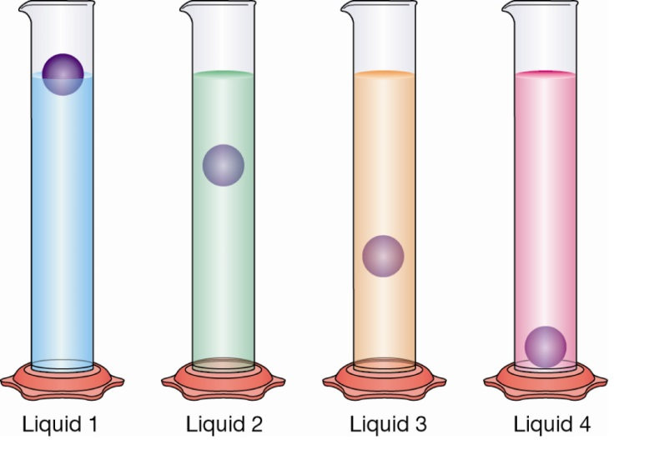

(a) liquid 1

(b) liquid 2

(c) liquid 3

(d) liquid 4

**8.** Mixing two substances together is a type of:

(a) Chemical reaction.

(b) Chemical change.

(c) Endothermic reaction.

(d) Physical change.

**9.** Corrosion is a:

(a) Chemical reaction where a metal reacts with oxygen.

(b) Physical reaction where a metal reacts with oxygen.

(c) Physical reaction where a non-metal reacts with oxygen.

(d) Chemical reaction where a non-metal reacts with oxygen.

**10.** Dry ice demonstrates an example of:

(a) Deposition.

(b) Boiling.

(c) Sublimation.

(d) Solidification

**11.** Which of the following statements about the diagram to the right is **INCORRECT**?

**[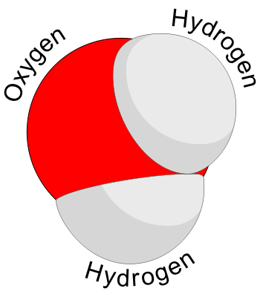](http://www.google.com.au/url?sa=i&rct=j&q=molecule&source=images&cd=&cad=rja&docid=nJD4iOsvbWrjXM&tbnid=0vKsvNnXoIgGEM:&ved=0CAUQjRw&url=http://www.webbofscience.com/2009/06/06/molecule-of-the-week-water/&ei=qRwUUs2NI8XNkwXr24GgDA&psig=AFQjCNGk0zhtDTBZU0Mi1OVQvLl8tANeNQ&ust=1377136159664223)**

(a) It is an element

(b) It is a molecule

(c) It is a compound

(d) It is water

**12.** Which of the following is **not** a type of physical change?

(a) Change in shape.

(b) A gas is given off.

(c) Expansion and contraction.

(d) Change of state.

**13.** This diagram shows three different ways of drawing the **same** thing. Which of the following statements about the diagram to the right is **INCORRECT**?

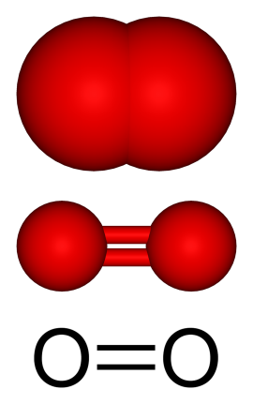

(a) It is an element

(b) It is a molecule

(c) It is a compound

(d) It is oxygen gas

**14.** Choose the correct definition for ‘sublimation’.

(a) A change of state from liquid to gas.

(b) A change of state from gas to solid.

(c) A change of state from solid to gas.

(d) A change of state from gas to liquid.

**15.** Choose the correct definition for ‘evaporation’.

(a) A change of state where a liquid changes to a gas at the surface of the liquid.

(b) A change of state from a solid to gas.

(c) A change of state where a liquid is heated and changes to a gas within the liquid

(d) A change of state where a gas is cooled and forms a liquid.

**SECTION B: SHORT ANSWER (26 marks)**

**1.** Explain the main difference between physical and chemical changes. (2 marks)

______________________________________________________________________________________________________________________________________________________________________________________________________________________________________________________________

_____________________________________________________________________________________

_____________________________________________________________________________________

_____________________________________________________________________________________

**2.** Label the diagram below (for the dotted lines only). (3 marks)

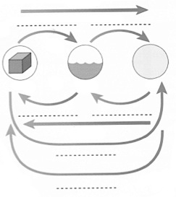

**3.** In the space below, draw a molecule with four atoms. (1 mark)

**4.** Label the products and the reactants for the chemical reaction below. (1 mark)

Fe + Cl2 ➔   FeCl2

**5.** When sodium hydroxide (NaOH) is mixed with hydrochloric acid (HCl), a salt called sodium chloride (NaCl), and water (H2O) are produced.

a) Write the word equation for this reaction. (1 mark)

**6.** When iron oxide (FeO) is heated in the presence of carbon monoxide (CO), they combine to produce carbon dioxide (CO2) and pure iron metal (Fe).

a) Write the word equation for this reaction. (1 mark)

**7.** Atoms can be created and destroyed during a chemical reaction. (1 mark)

(Circle your answer) True or false

8a. A wooden cube has a volume of 5cm3 and a mass of 5g. Calculate its density. Show all working.

(3 marks)

8b. Would the wooden block in question 8a float in water? Give a reason for your answer.

(2 marks)

**9.** Fill in the table below, which relates to the particle model. (5 marks)

|  |  |  |  |
| --- | --- | --- | --- |
|  | **Solids** | **Liquids** | **Gases** |
| **Shape** | Hold their own shape. |  |  |
| **Compressibility** |  | Are incompressible. |  |
| **Strength of**  **bonds**  **between**  **particles** |  |  | None. |
| **Movement**  **of particles** | Vibrate on the spot. |  |  |
| **Space between**  **particles** |  | Almost none. |  |

**10.** List two observations that could be made when a chemical change has occurred. (2 marks)

_____________________________________________________________________________________

_____________________________________________________________________________________

_____________________________________________________________________________________

**11.** In the table below, write whether the processes are physical or chemical changes. (4 marks)

|  |  |
| --- | --- |
| **Process** | **Chemical change or physical change** |
| Crushing a can |  |
| An egg rotting |  |
| Burning a match |  |
| Snapping a pencil in half |  |
| Mixing blue and red paint together to form a  purple colour |  |
| Mixing milo in milk |  |
| Green apple ripening to turn red |  |
| An ice-cream melting |  |